Title or Task: | 

Description:

Files Required
Suitable for Classes: | AIT • Multimedia • Cert II IT • Cert II Bus
Area: | Technology & Enterprise
Teacher: | Mr Peter Faulks

Timeline

Date Due:

Task Brief:

Outcomes:

Items highlighted in yellow are tasks for you to complete
Items in Blue italics are help tips

APPLIED INFORMATION TECHNOLOGY

Week 8 Evaluation Test 2

Name:___________________________________________

Part 1 Task –

IMPORT TEXT AND GRAPHICS TO CREATE A MENU (FOR PRINTING)
Maximum marks 100

Time allowed for this paper
Reading/planning time before commencing work: Ten minutes
Working time for paper: One lesson

Material required/recommended for this paper

To be provided by the supervisor
This Question Paper

To be provided by the candidate
Standard items: Computer any relevant software

Special items: Use of Format Painter and Tables is expected.

Important note to candidates
No other items may be taken into the examination room. It is your responsibility to ensure that you do not have any unauthorised notes or other items of a non-personal nature in the examination room. If you have any unauthorised material with you, hand it to the supervisor before reading any further.

Evaluation Test Starts next page Note the text and questions are for you to decipher – your task is to sort this out and make the menu look great!
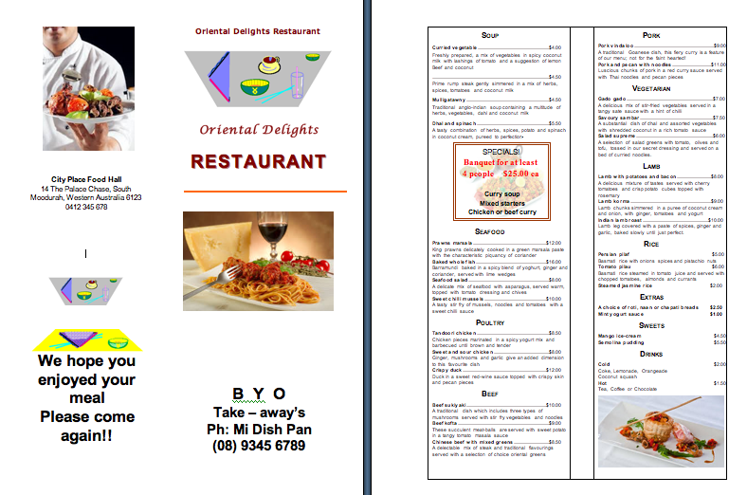
Part 1 Extended project

Topic: IMPORT TEXT AND GRAPHICS INTO A PUBLICATION

Your task is to create a menu for the Oriental Delights Restaurant.
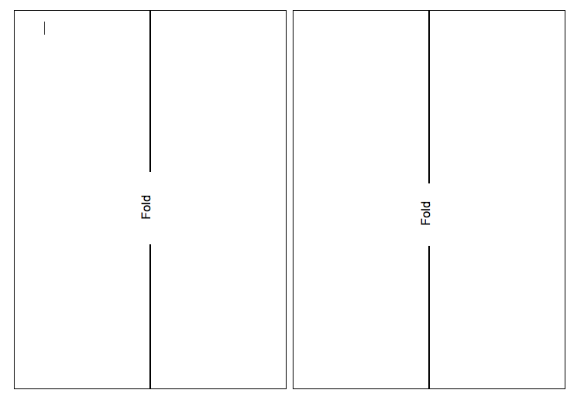
The menu consists of 4 sections and is to be printed on 2 sheets of A4 paper reversed back to back to make a reverse printed menu with orientation, portrait. Print out 2 separate pages if you cannot print reverse pages. I will glue them together.
The menu will be folded as shown on the right.
Most of the text is already typed (see below) , but will need to be formatted.
Graphics are already prepared and saved in the files ITEM25A.DOC. ITEM25B.BMP and ITEM25C.BMP. (On this page)
Download to your marks folder 5 marks
Menu Cover (page 1)
The cover page is to the right of the back page, (page four), in the illustration.

1. Insert at the top of page 1, the text: You select font type.

Oriental Delights Restaurant
2 marks
2. Center at the bottom of the page place:
B Y O
Take-aways
Phone:
Your Name
Ph: (08) 9234 5678
4 marks
3. Insert the graphics, Item25B.bmp and place it as shown.
4 marks
4. Add the line below the word Restaurant.
2 marks

Save the file to AIT Tests folder as Your Initials_MYMENU 4 marks

Back Page (Page 4)
Address

City Place Food Hall
14 The Palace Chase, South Moodurah, Western Australia 6123

5. At the bottom of the page insert the text: You choose the font.
We hope you enjoyed your meal
Please come again!!
The Manager: (Your Name)
2 marks
(The text at the top of the page will be inserted later.)

6. Insert the graphics, Item25C.BMP and place it as shown on the previous page.
4 marks

Graphics
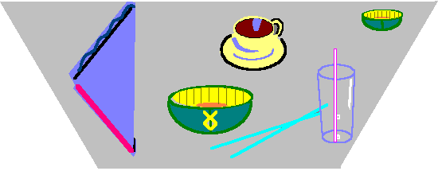item 25b

item 25c


7. Add a line above the graphics.
2 Marks
Pages 2 and 3
Most of the text on these pages is found below or in the file ITEM25A.DOC.

Soup

Curried vegetable $4.00
Freshly prepared, a mix of vegetables in spicy coconut milk with lashings of tomato and a suggestion of lemon

Beef and coconut $4.50
Prime rump steak gently simmered in a mix of herbs, spices, tomatoes and coconut milk

Mulligatawny $4.50
Traditional anglo-indian soup containing a multitude of herbs, vegetables, dahl and coconut milk

Dhal and spinach $5.50
A tasty combination of herbs, spices, potato and spinach in coconut cream, pureed to perfection.

Starters

Vegetable pakoras $5.00
A savoury selection of deep fried vegetables in a chickpea flour batter with a mint and yogurt sauce

Samosas (4) $4.00
Your choice of meat or vegetable samosas
Enjoy the subtle taste of mint and chilli in parcels of beef wrapped in a crisp pastry and deep fried
Perhaps you’d prefer a mix of vegetables and coriander with fragrant spices deep fried in the same crisp pastry

Potato and lentil patties $5.00
A spicy mix of ingredients delicately browned, served with a tangy tamarind sauce

Seafood

Prawns marsala $12.00
King prawns delicately cooked in a green marsala paste with the characteristic piquancy of coriander

Baked whole fish $16.00
Barramundi baked in a spicy blend of yoghurt, ginger and coriander, served with lime wedges

Seafood salad $8.00
A delicate mix of seafood with asparagus, served warm, topped with tomato dressing and chives

Sweet chilli mussels $10.00
A tasty stir fry of mussels, noodles and tomatoes with a sweet chilli sauce

Poultry

Tandoori chicken $8.50
Chicken pieces marinated in a spicy yogurt mix and barbecued until brown and tender

Sweet and sour chicken $8.00
Ginger, mushrooms and garlic give an added dimension to this favourite dish

Crispy duck $12.00
Duck in a sweet red-wine sauce topped with crispy skin and pecan pieces

Beef

Beef sukiyaki $10.00
A traditional dish which includes three types of mushrooms served with stir fry vegetables and noodles

Beef kofta $9.00
These succulent meat-balls are served with sweet potato in a tangy tomato masala sauce

Chinese beef with mixed greens $8.50
A delectable mix of steak and traditional flavourings served with a selection of choice oriental greens

Lamb

Lamb with potatoes and bacon $8.00
A delicious mixture of tastes served with cherry tomatoes and crisp potato cubes topped with rosemary

Lamb korma $9.00
Lamb chunks simmered in a puree of coconut cream and onion, with ginger, tomatoes and yogurt

Indian lamb roast $10.00
Lamb leg covered with a paste of spices, ginger and garlic, baked slowly until just perfect.

Pork

Pork vindaloo $9.00
A traditional Goanese dish, this fiery curry is a feature of our menu; not for the faint hearted!

Pork and pecan with noodles $11.00
Luscious chunks of pork in a red curry sauce served with Thai noodles and pecan pieces

Vegetarian

Gado gado $7.00
A delicious mix of stir-fried vegetables served in a tangy sate sauce with a hint of chilli

Savoury sambar $7.50
A substantial dish of dhal and assorted vegetables with shredded coconut in a rich tomato sauce

Salad supreme $6.00
A selection of salad greens with tomato, olives and tofu, tossed in our secret dressing and served on a bed of curried noodles.

Rice

Persian pilaf $5.00
Basmati rice with onions spices and pistachio nuts

Tomato pilau $6.00
Basmati rice steamed in tomato juice and served with chopped tomatoes, almonds and currants

Steamed jasmine rice $2.00

Extras

A choice of roti, naan or chapati breads $2.50

Mint yogurt sauce $1.00

Sweets

Mango ice-cream $4.50

Semolina pudding $5.50

Drinks

Cold $2.00
Coke, Lemonade, Orangeade
Coconut squash

Hot $1.50
Tea, Coffee or Chocolate

8. Place the text from this file on page 2. Let it flow onto pages 3 and 4.
4 marks
9. Format the text to suit the menu
Adjust the formatting so the text appears as shown in the sample shown above.
15 marks
Images
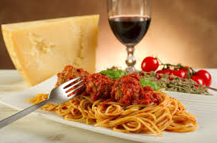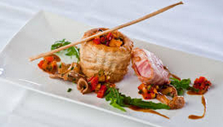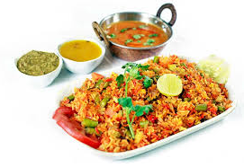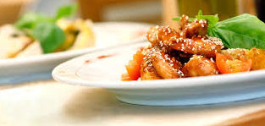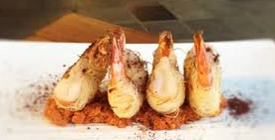
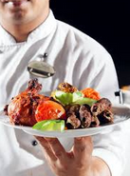
10. In a separate text box type the details of the specials shown below. (These are not included in the text you have just inserted).
Add the line below the word SPECIALS.
10 marks

11. Position the text box so it appears between the starters and the seafood.
4 marks
12. Add some form of fill/shading to make the specials conspicuous.
5 marks
13. Adjust the text frames so a heading: is at the top of page 4.
2 marks
14. Carefully adjust the text frames so that the headings: Soup
is exactly level with a heading at the top of pages 2 and 3 respectively.

5 marks
15. Include your name on the menu and Save the file replacing
Your Initials_MYMENU .
2 marks

16. Make changes to the menu as you feel necessary to improve the overall appearance of the menu. Save this as your initials MYMENU2.doc

18 marks
17. Print two copies:-
1. A copy of your document that matches to one requested in this exam . Fold it and hand in before the end of the exam.
3 marks

2. A copy of your improved final document. Fold it and hand in before the end of the exam.
3 marks

END OF QUESTIONS

Check that you have written your Student Name on the menu, and hand in your completed menus (original and your improved copy) to Mr Faulks.



